PACKET OUTLINE: EARTH’S ATMOSPHERE
- Volcanoes created the atmosphere when they released large amounts of gas in a process called OUTGASSING
- Early gasses interacted with sunlight and organisms and became modified-
  - Ammonia was split to produce nitrogen gas (N₂)
  - Water was split to produce the oxygen that immediately become ozone (O₃)
  - Most Oxygen gas was produced when blue green algae evolved to use the sunlight during photosynthesis (O₂)
  - Carbon dioxide levels decreased because of photosynthesis

- Today’s gasses include: Nitrogen 78%; Oxygen 21%; trace amounts of carbon dioxide and water vapor and other gasses.
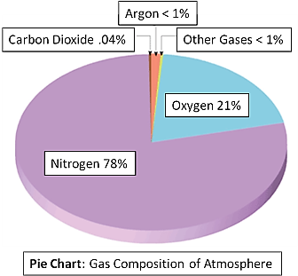
      - Oxygen and carbon dioxide levels are maintained by the balance between photosynthesis and respiration
      - Water vapor is maintained by the water cycle
      - Nitrogen levels are maintained by the nitrogen cycle
Temperature, Pressure and density trends in the atmosphere:
- 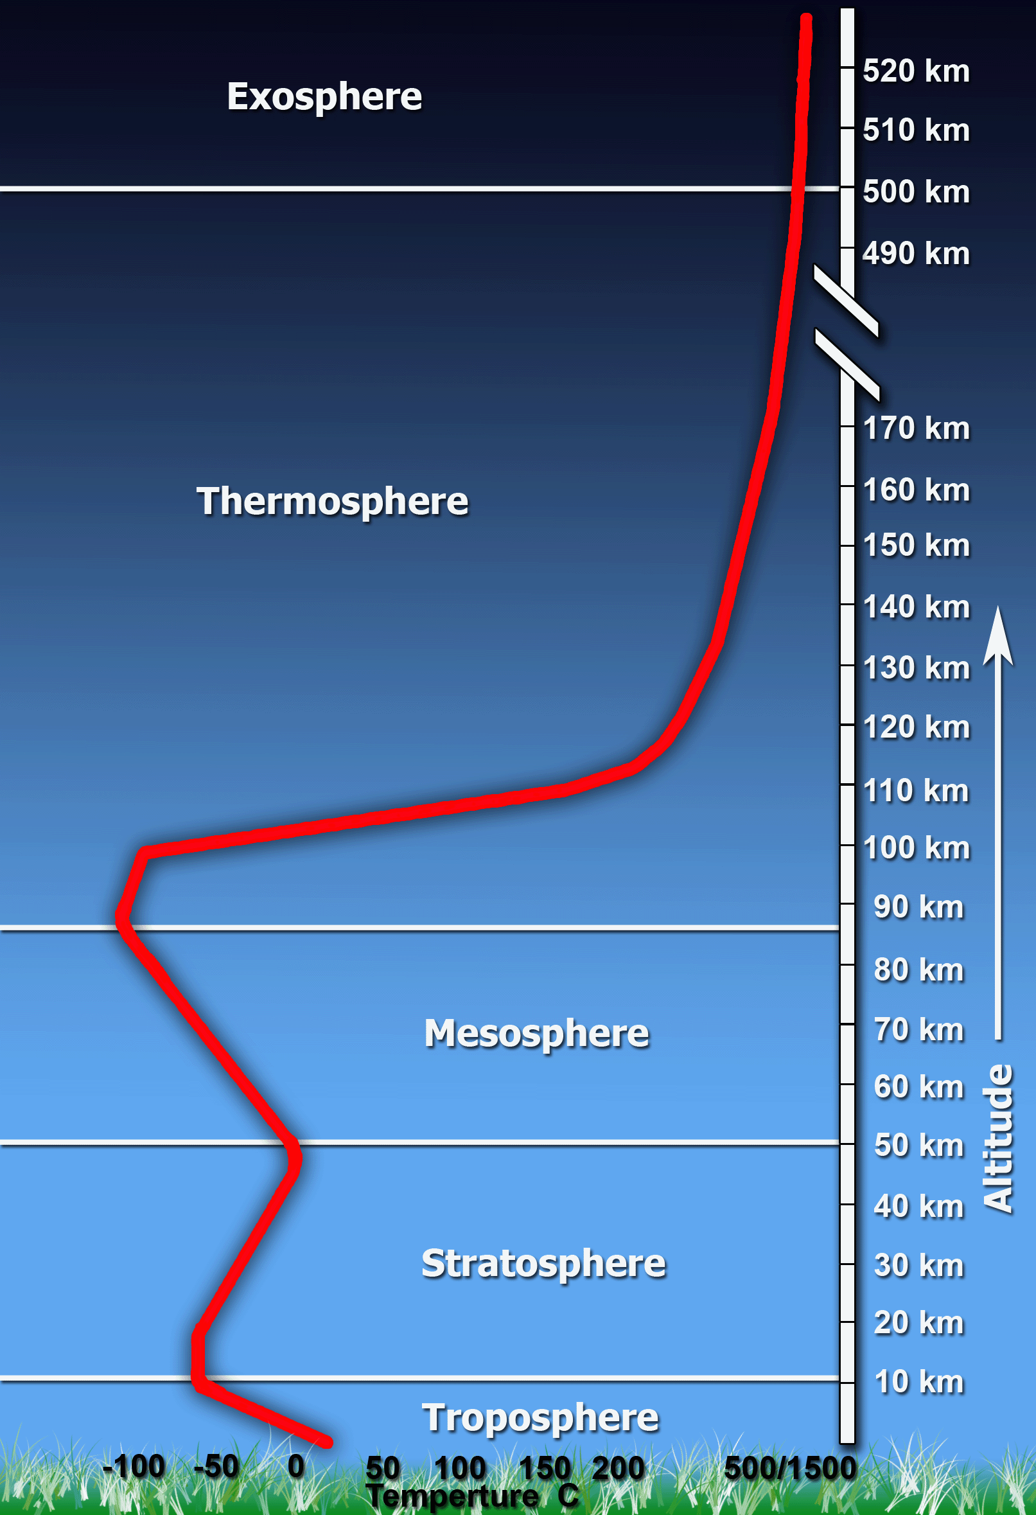
- Temperature DECREASES with altitude in TROPOSHPERE
- Temperature INCREASES with altitude in the STRATOSPHERE
- Temperature DECREASES with altitude in the MESOSPHERE
- Temperature INCREASES with altitude in the THERMOSPHERE
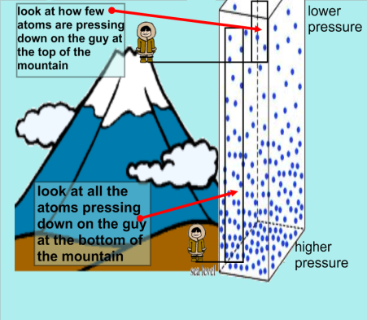
- Air PRESSURE DECREASES with altitude in all layers
- Air Density DECREASES with altitude in all layers
Temperature Inversions in the troposphere:
- Temperature increases as you go higher in altitude in the troposphere when there is an inversion
- Occurs when warm air traps cool air underneath it
- Increases pollution because the cold air is very dense and cannot rise away from the city, therefore does not carry away the smog from the city
- Can be spotted on a graph by a “flip” in the slope showing an increase in temperature
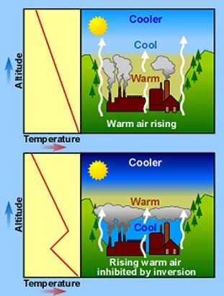
Ozone in the stratosphere:
- Ozone absorbs UV rays, protecting life and preventing some of the sun’s energy from warming the ground. The hole in the ozone allows more UV light to enter the atmosphere, causing cancers and damaging plant tissue.
Meteors burn up in the Mesosphere
- The air molecules in the mesosphere rub against falling meteors. The resulting friction then heats and burns them up. The mesosphere protects us from impacts with meteors (remember the one that fell in Mexico and killed the dinosaurs!)

The Thermosphere absorbs X and Gamma Rays
- The outmost layer of air absorbs high energy gamma and x rays before most of them can reach the surface of the earth.
- The thermosphere includes the ionosphere and the exosphere.
- The auroras or northern and southern lights can be seen in the ionosphere.
- Cell phone and radio communication depends on waves bouncing off the ionosphere
- 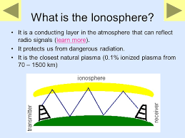

ALBEDO OF EARTH SURFACES
- Albedo is the reflectivity of surfaces. Light colored surfaces have high albedo.
- Snow and ice/glaciers provide the planet’s albedo
- Snow and ice reflect sunlight and keep the planet a little cooler
- The ice-albedo positive feedback occurs when the ice melts and the earth absorbs more sunlight, gets warmer and melts more ice. This repeats itself and is called a positive feedback or vicious cycle.
- Melting ice lowers Earth’s albedo

